**EXPERIMENT 18**

**Create a Storage service using any Public Cloud Service Provider (Azure/GCP/AWS) and check the public accessibility of the stored file to demonstrate Storage as a Service.**

STEP 1: CREATE A STORAGE ACCOUNT GO TO THE BASICS.

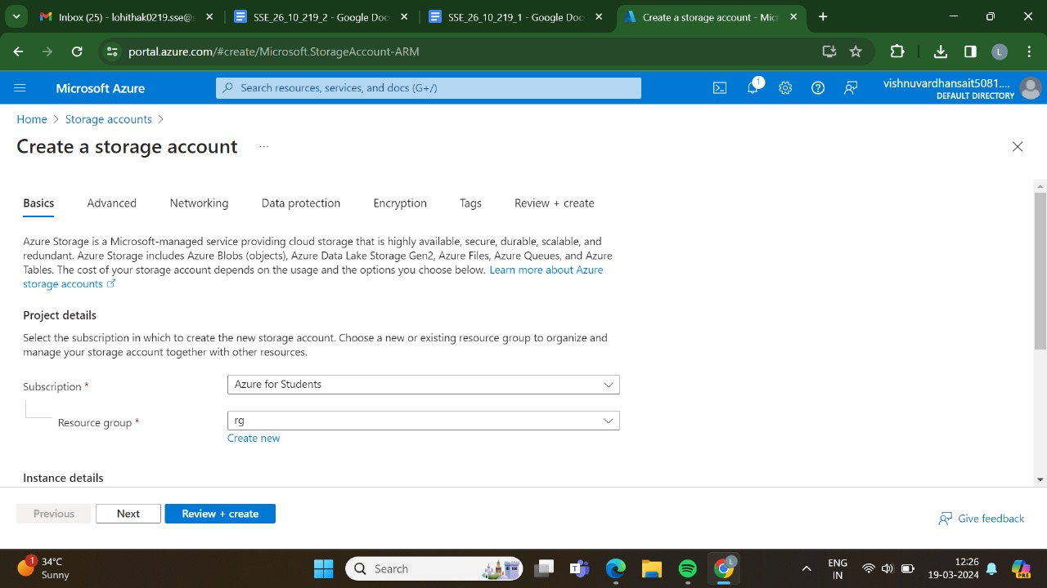

STEP 2: AND, THEN GO TO THE ADVANCED.

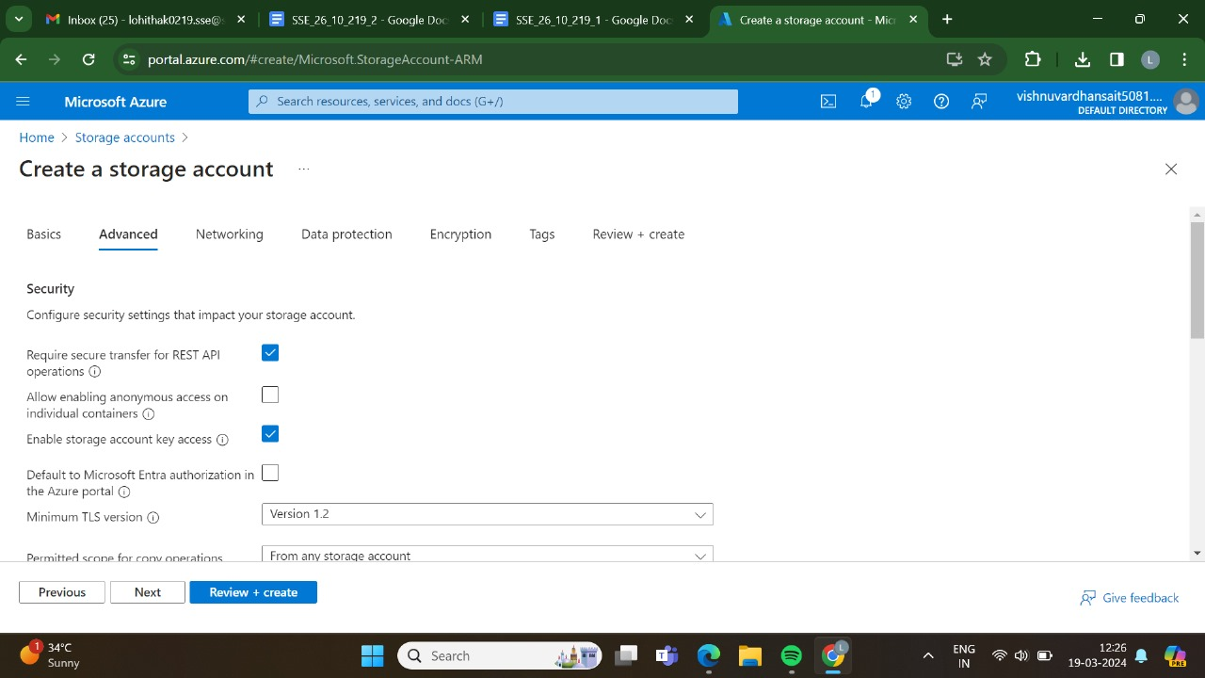

STEP 3: AND, THEN GO FOR THE NETWORKING.

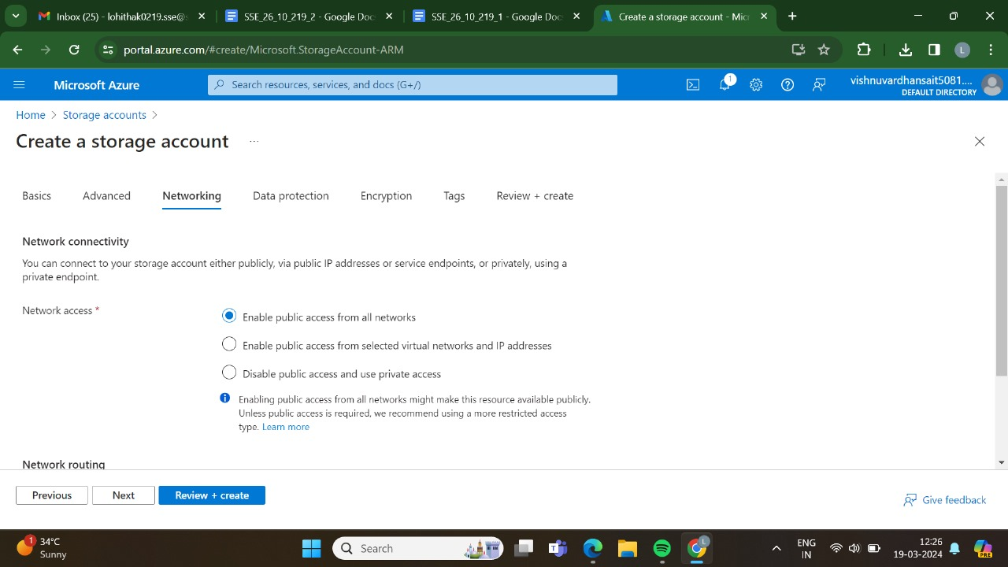

STEP 4: AND, THEN GO FOR THE DATA PROTECTION.

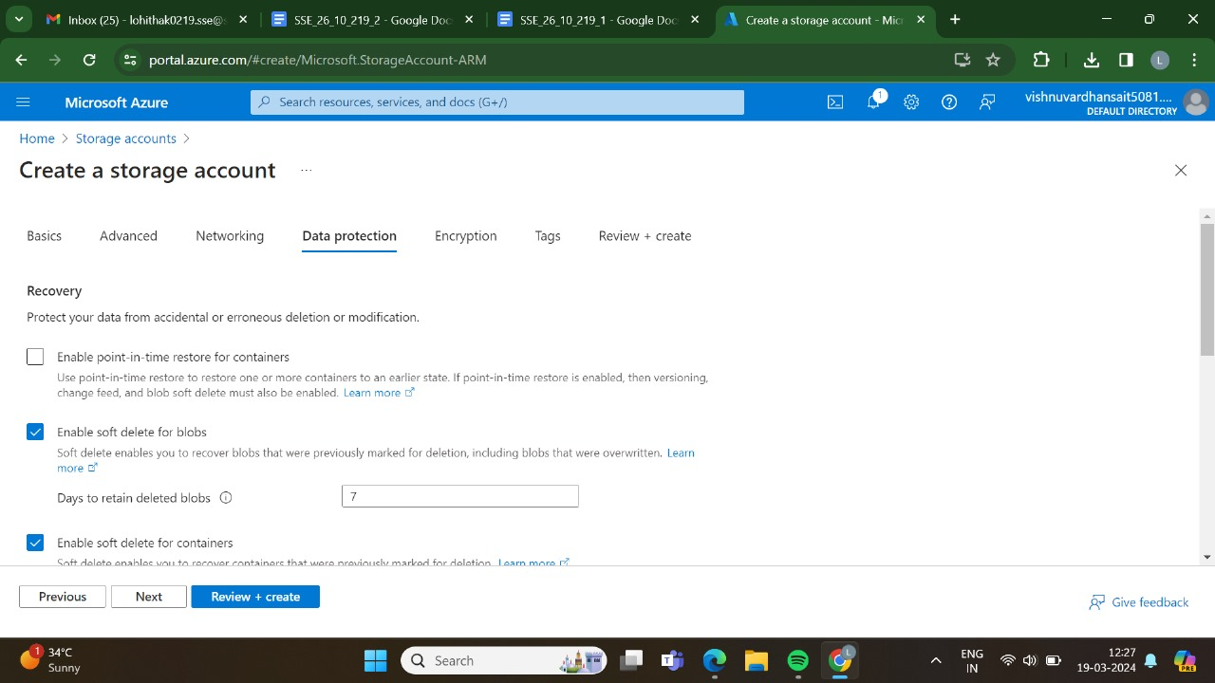

STEP 5: AND, THEN GO FOR THE ENCRYTION.

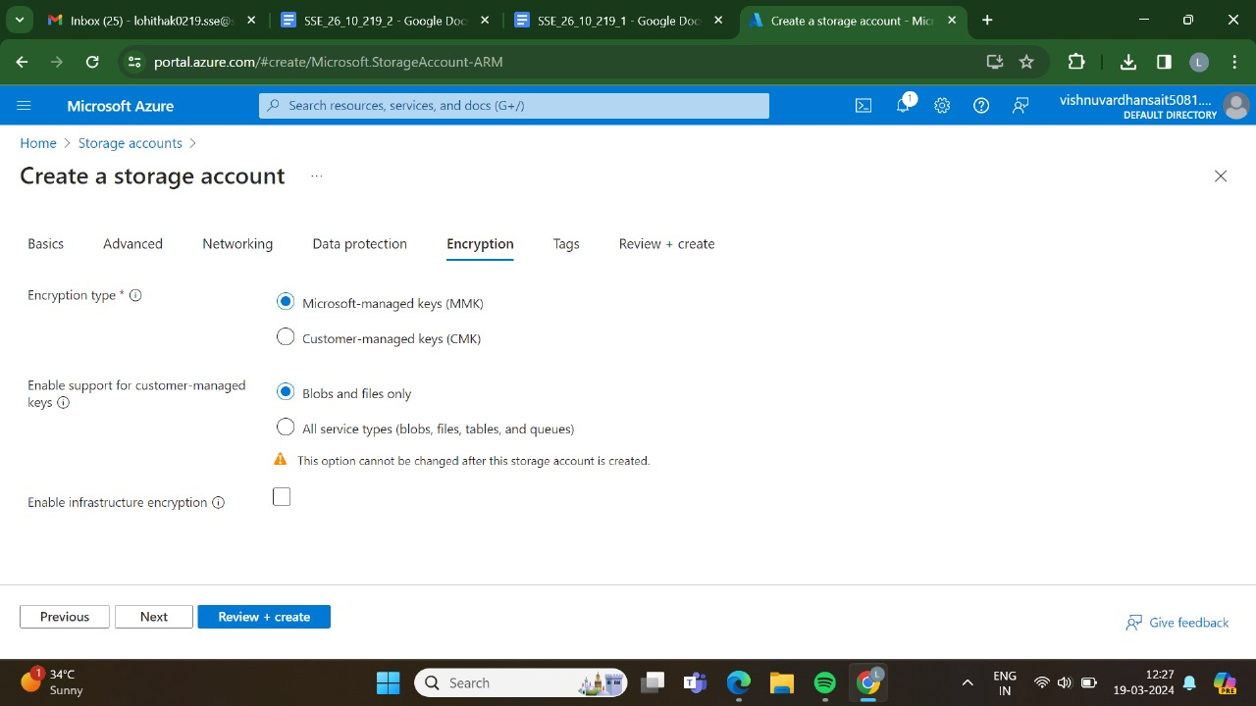

STEP 6: AND, THEN GO FOR THE TAGS.

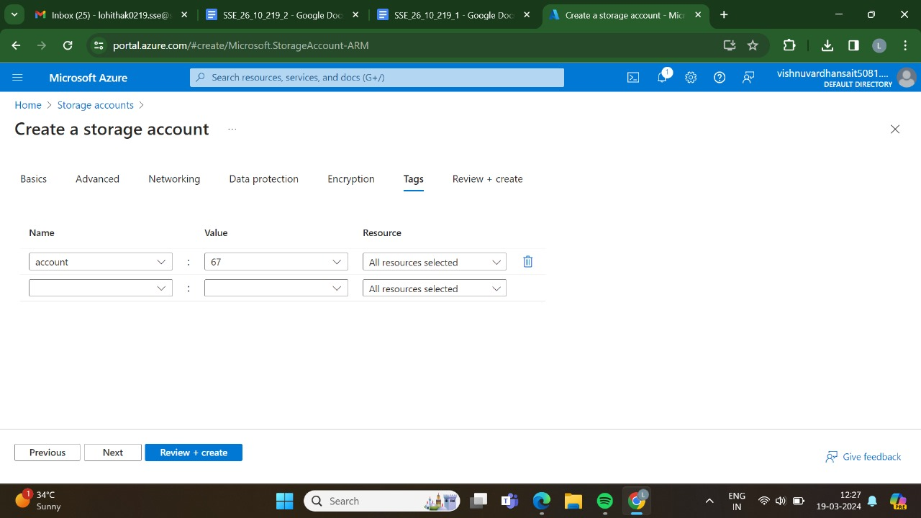

STEP 7: AT LAST GO FOR THE REVIEW + CREATE , AND CLICK CREATE.

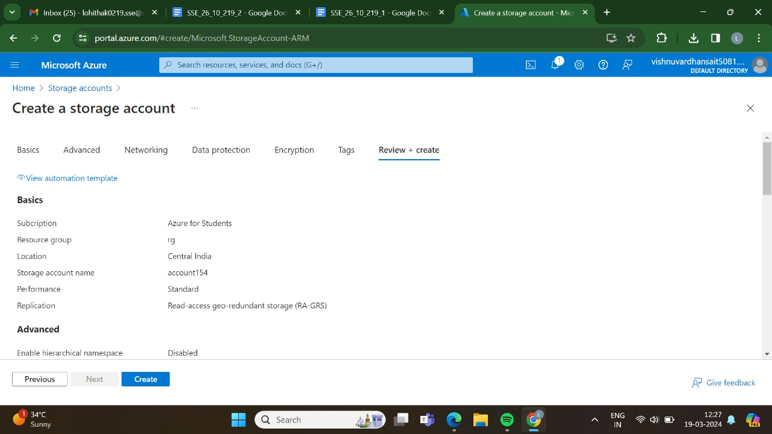

STEP 8: DEPLOYMENT IS IN PROGRESS.

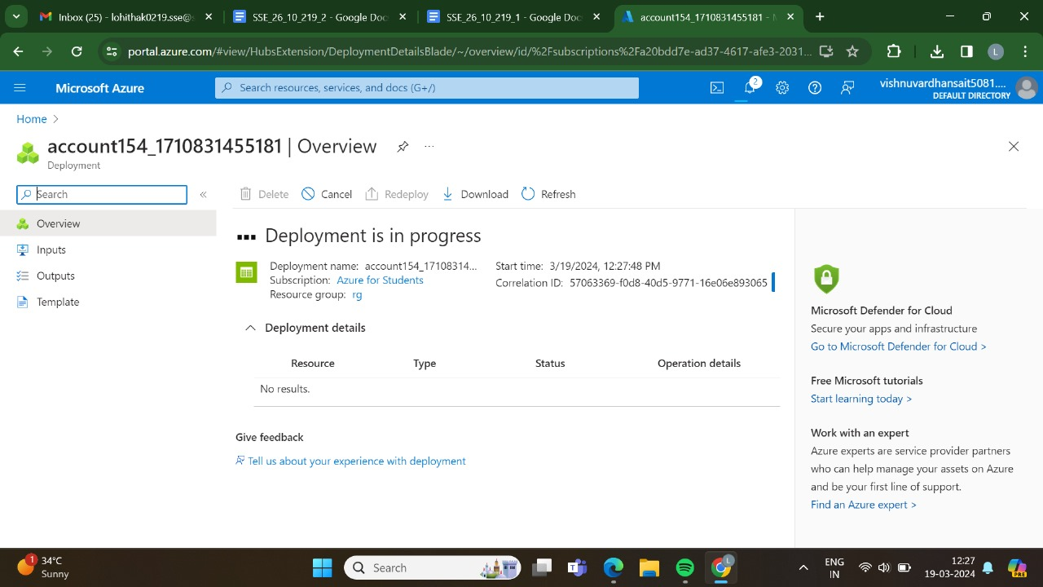

STEP 9: DEPLOYMENT HAS BEEN DONE SUCCESSFULLY.

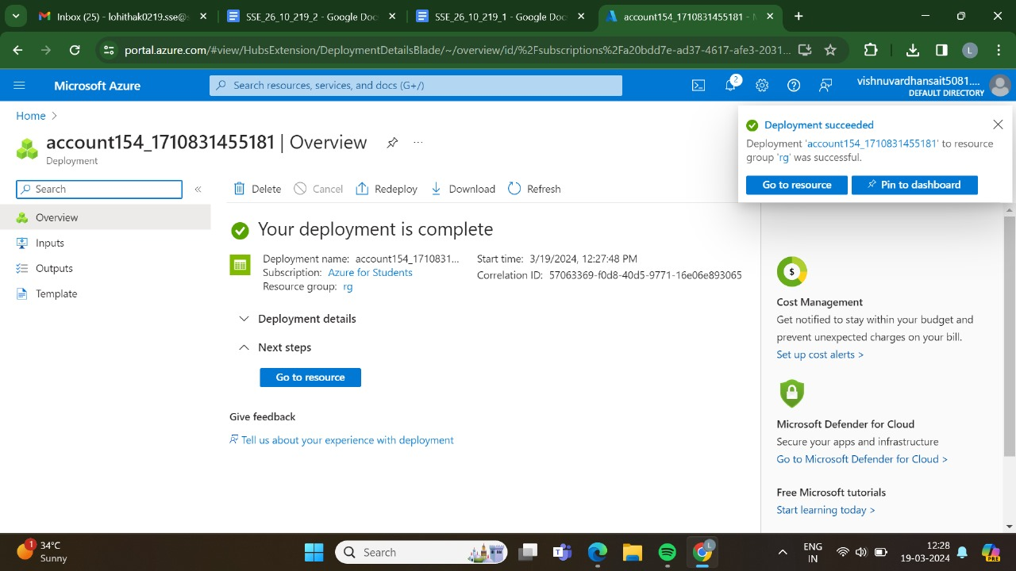

STEP 10: AND THEN GO FOR THE STORAGE BROWNSER.

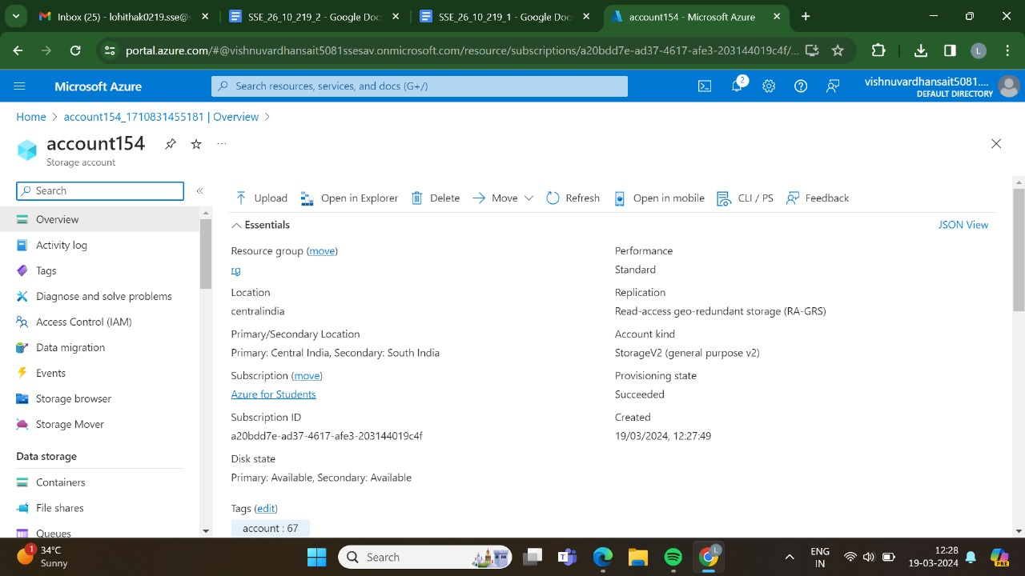

STEP 11: AND THEN GO TO THE FILE SHARES.

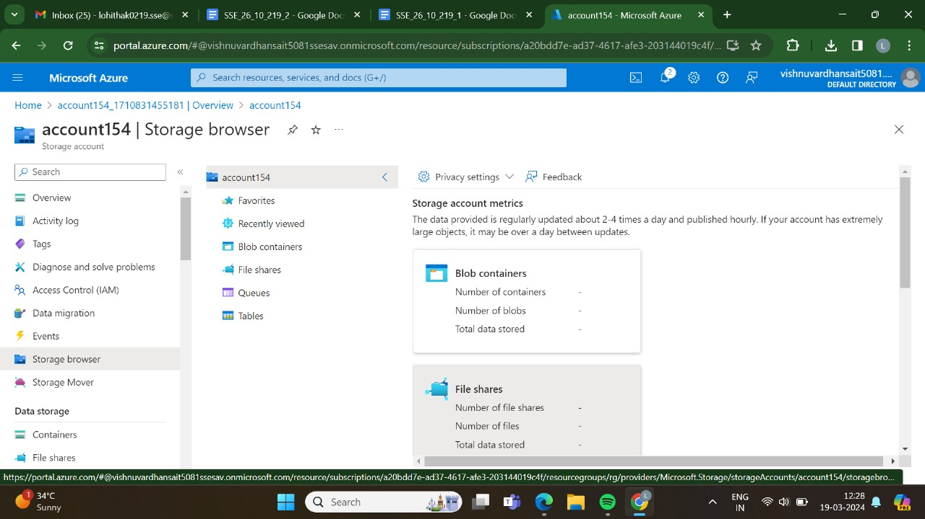

STEP 12: AND THEN CREATE A NEW FILE SHARE.

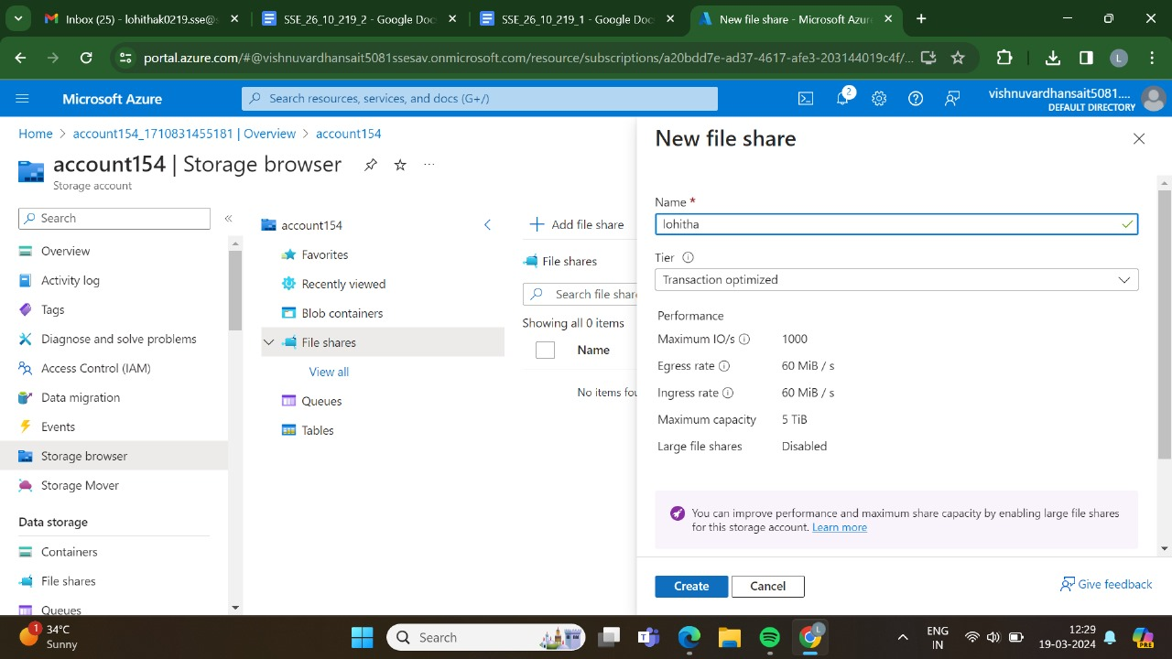

STEP 13: HAS BEEN DONE SUCCESSFULLY.

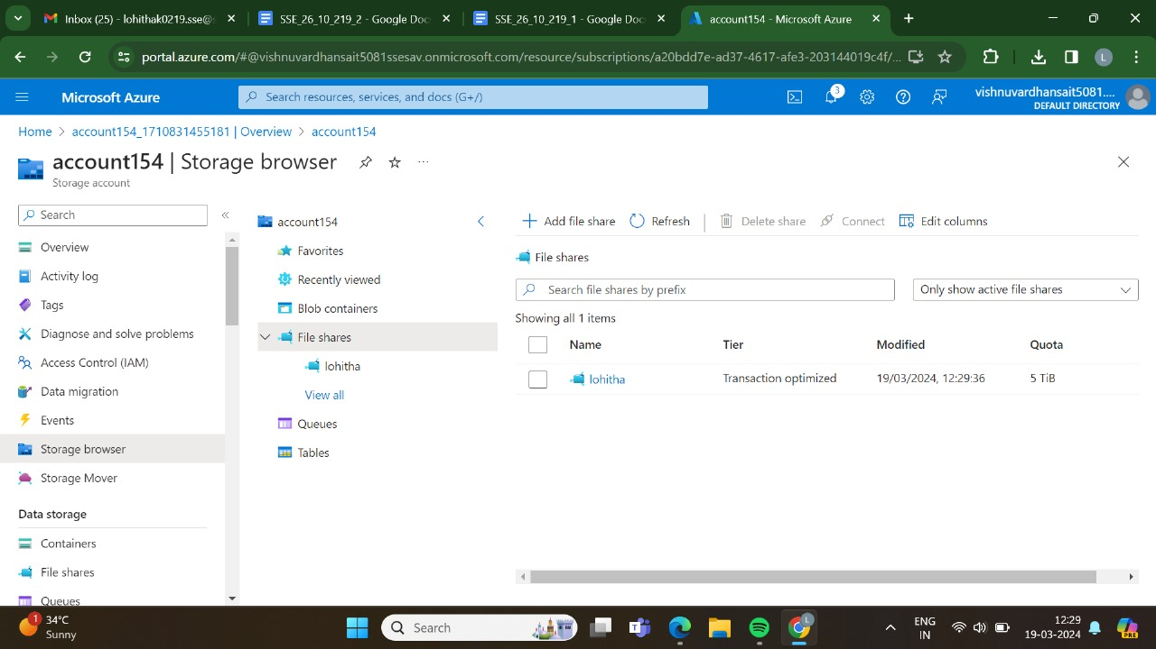

STEP 14: AND THEN GO AND UPLOAD THE FILES.

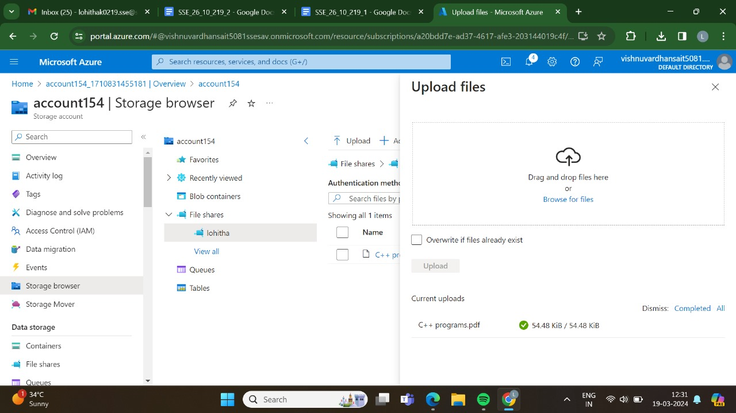

STEP 15: AT LAST THE FILE HAS BEEN UPLOADED SUCCESSFULLY.

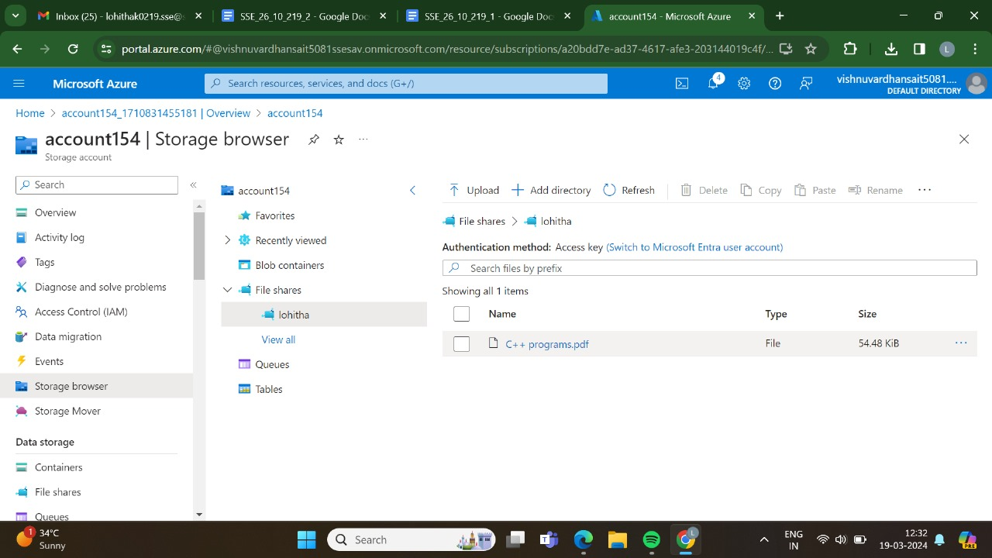

RESULT: THUS,THE PROGRAM HAS BEEN EXCEUTED SUCCESSFULLY.